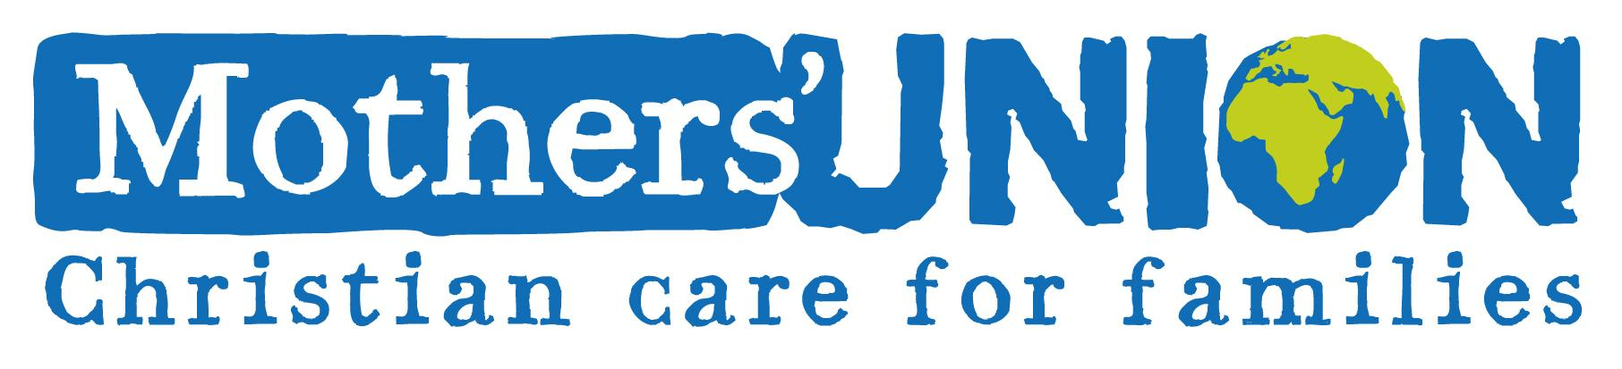
Jill Cannings Branch leader in Uppingham will be attempting to play 140 holes of golf W/C June 6th 2016. All funds raised will go to support the work of the Mother’s Union in developing countries. Your support will be much appreciated whether financially or prayerfully. Please record information below. It would be helpful if someone can collect funds on behalf of a branch. Cheques should be made payable to Mother’s Union Uppingham branch. If you have any queries my phone number is 01572 821870
Name | Amount | Paid

I also have a giving site which is easy to use and sorts out gift aid
It is:
www.justgiving.com/Jill-Cannings3

